LO: To recognise a range of ingredients?
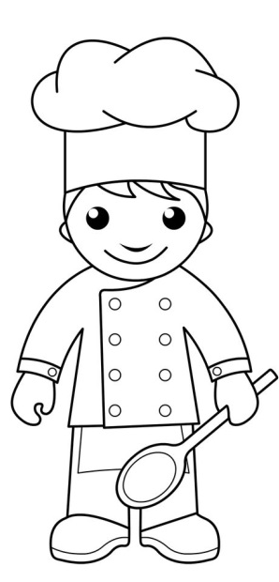
TASK: Draw and colour in the layers of different foods in the pot. Use the words below to help you. missing ingredients. Use the word bank to help you. el and colour in the ingredients and then draw the missing ingredients. Use the word bank to help you. Label and colour in the ingredients and then draw the missing ingredients. Use the word bank to help you.

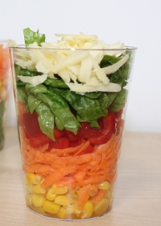

Cheese Lettuce Pepper Carrot Sweetcorn

