Stripy Salad Pots
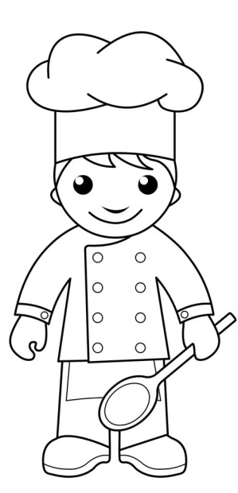
Serves 2 pots
Children can chop and layer the different vegetables identifying the colours and names to create a Stripy Salad Pot.


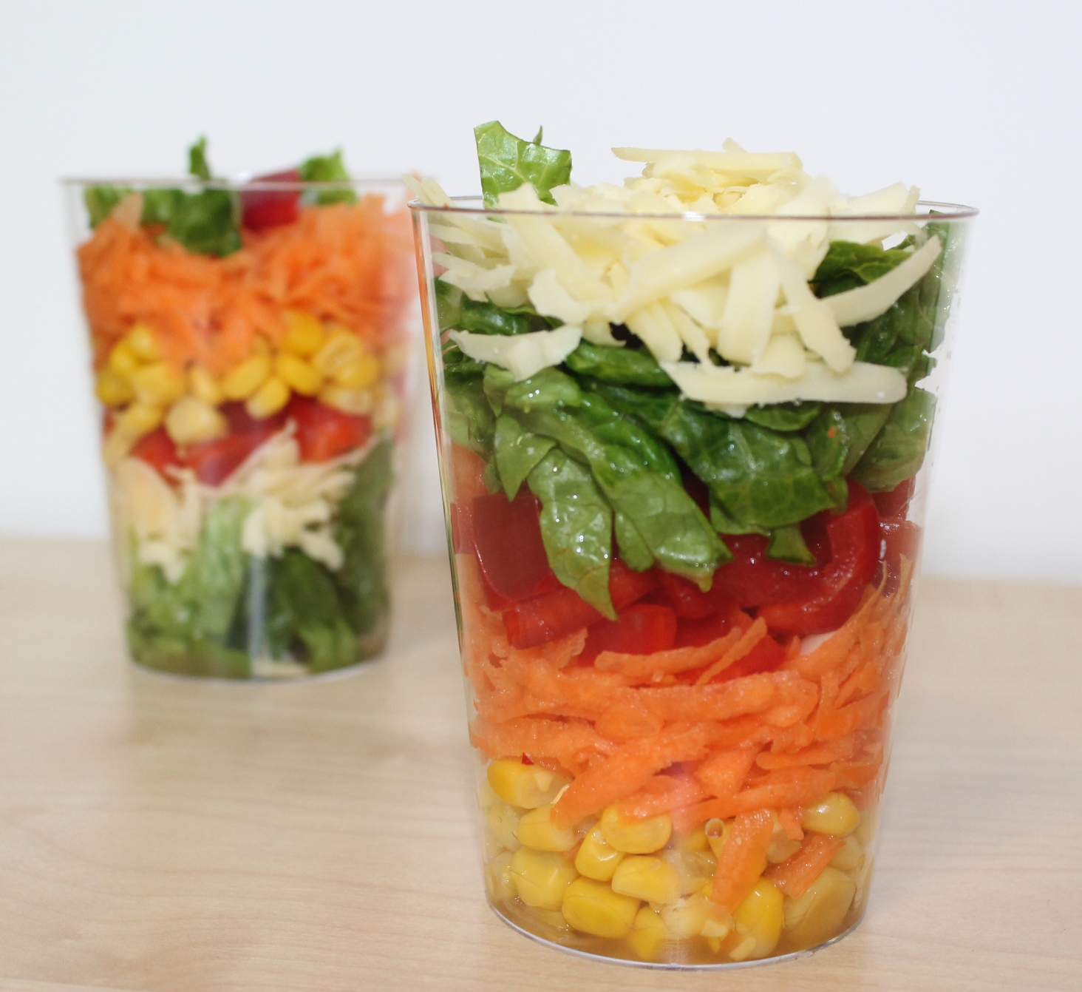
Ingredients
30g Cheddar cheese
1 small carrot
1/2 red pepper, deseeded
2 x lettuce leaves
4 x 15ml spoons sweetcorn

Equipment
Chopping board, plastic grater, plate, safety vegetable knife, peeler, kitchen scissors, 2 clear jars or plastic glasses.

Method
- Grate the cheese.
- Top, tail, peel and grate the carrot.
- Use scissors to snip the pepper into strips and then into small pieces.
- Cut the lettuce leaves into thin strips.
- Arrange the ingredients in layers in the cup.
Extras
You could add other ingredients to your salad pot:
- chopped cherry tomatoes, grapes or olives
- grated courgette
- canned tuna
- cooked prawns
- sliced ham or chicken

