Safety measures
Are you safe when you prepare, cook and store foods?
List the different ways you keep safe.

To get ready to cook, I...
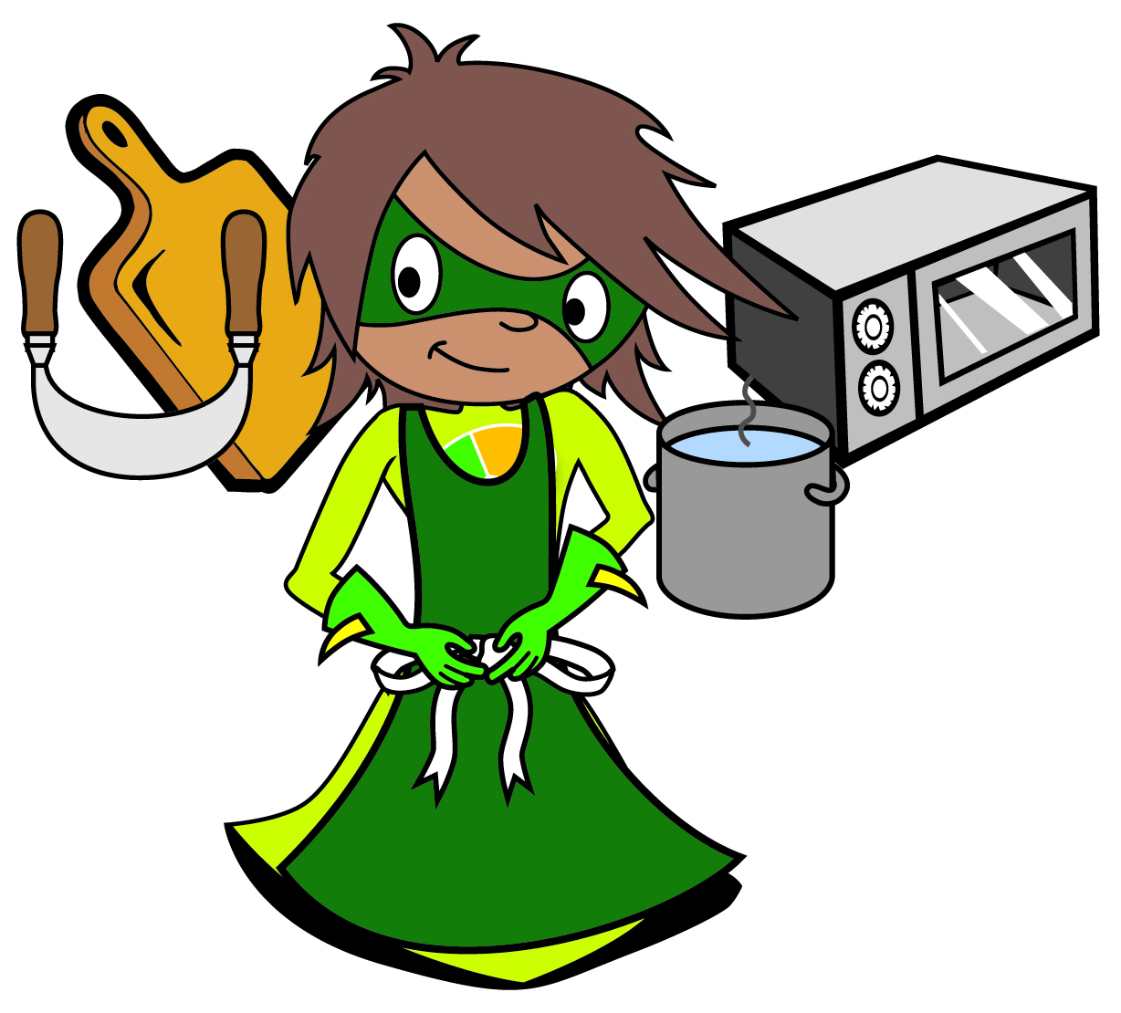
To cook safely, I…

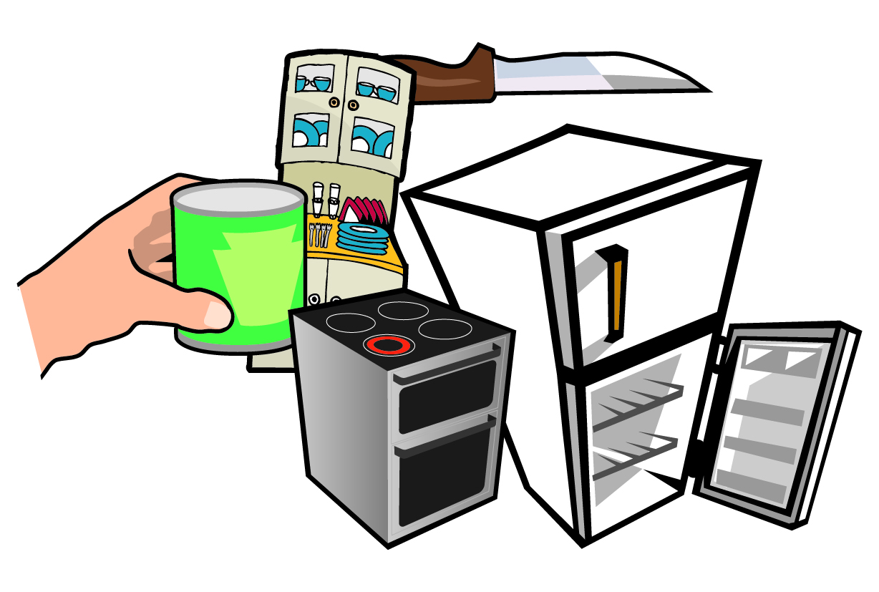
To store foods safely, I…

© Crown Copyright 2016

